Practical 9
Using 8 x 8 LED Matrix with Raspberry Pi

To interface a 8 x 8 LED Matrix7219 with Raspberry Pi 3 and display a diagonal line, square, Alphabet “A” and a message scrolling on it.

8 x 8 LED Matrix7219: -
An 8×8 LED Matrix consists of 64 LEDs arranged in rows and columns to display characters and patterns. The MAX7219 is a driver IC used to control the matrix easily using SPI communication. It handles LED scanning, brightness control, and reduces the number of microcontroller pins required. This combination is widely used for text display, animations, and embedded system projects.

Components Required: -
- 8 x 8 LED matrix7219
- Jumper Wires
- Install the Driver Library

Settings to be done: -
- On terminal type - sudo raspi-config
- Go To - Interface Options → SPI → Enable
- Reboot the Raspberry Pi
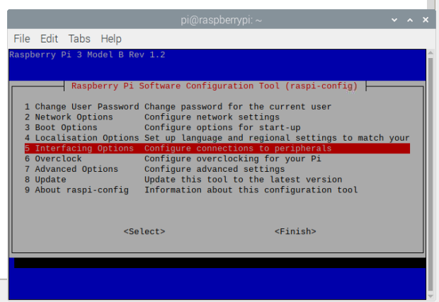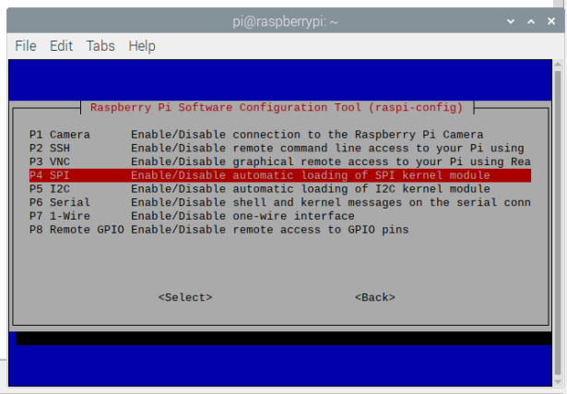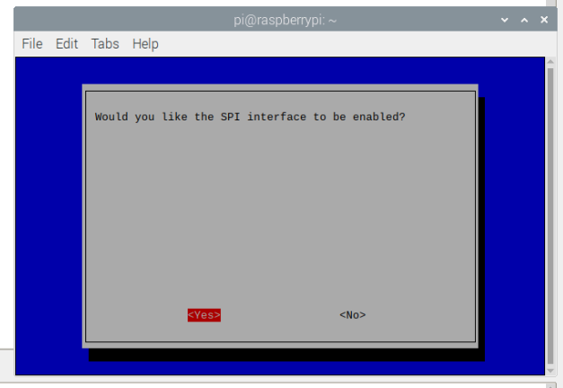

Install Driver: -
Go to Thonny > Above Tab Tools > Manage Packages > install (update, pip, luma.led_matrix)
Or Through terminal -
- sudo apt update (optional if installed already)
- sudo apt install -y python3-pip (optional it installed already)
- pip3 install luma.led_matrix
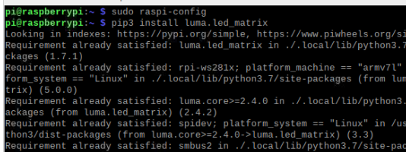

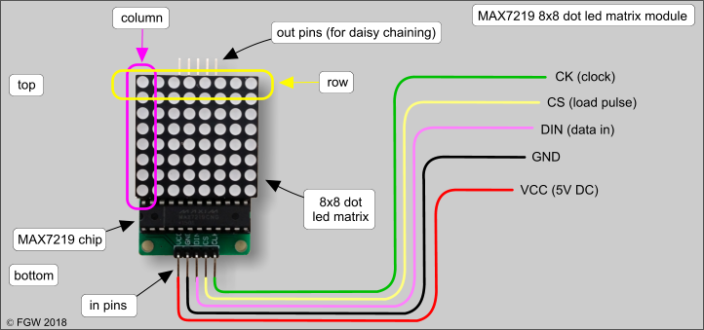
Pin Connections
MAX7219 Pin | Raspberry Pi Physical Pin | GPIO Numbering
VCC | Pin 1 | 3.3V
GND | Pin 6 | Ground
DIN | Pin 19 | MOSI (GPIO10)
CS / LOAD | Pin 24 | CE0 (GPIO8)
CLK | Pin 23 | SCLK (GPIO11)

| MAX7219 Pin | Raspberry Pi Physical Pin | GPIO Numbering |
|-------------|--------------------------|------------------------|
| VCC | Pin 1 | 3.3V |
| GND | Pin 6 | Ground |
| DIN | Pin 19 | MOSI (GPIO10) |
| CS / LOAD | Pin 24 | CE0 (GPIO8) |
| CLK | Pin 23 | SCLK (GPIO11) |
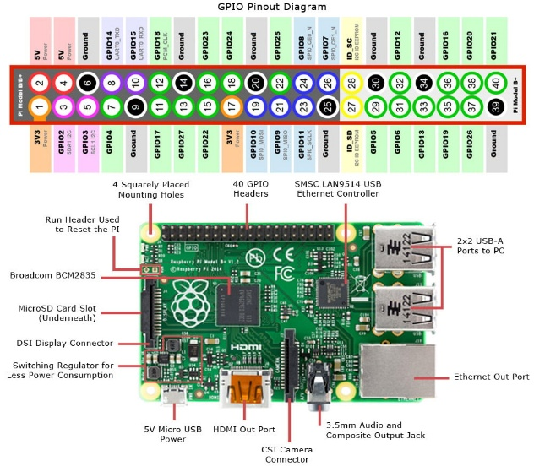

Code: -
from luma.core.interface.serial import spi, noop
from luma.led_matrix.device import max7219
from luma.core.render import canvas
from luma.core.legacy import show_message, text
from luma.core.legacy.font import proportional, CP437_FONT
import time

# Uses /dev/spidev0.0 (SPI0 CE0)
serial = spi(port=0, device=0, gpio=noop())

# For a single 8x8 matrix
device = max7219(serial, cascaded=1, block_orientation=90, rotate=0)
device.contrast(50) # 0-255 (increase if needed)

print("MAX7219 8x8 Matrix Ready...")

def blink_dot():
with canvas(device) as draw:
draw.point((3,3), fill="white")
draw.point((4,3), fill="white")
draw.point((4,4), fill="white")
draw.point((3,4), fill="white")

def diagonal_line():
with canvas(device) as draw:
for i in range(8):
draw.point((i, i), fill="white")

def border_box():
with canvas(device) as draw:
for x in range(8):
draw.point((x, 0), fill="white")
draw.point((x, 7), fill="white")
for y in range(8):
draw.point((0, y), fill="white")
draw.point((7, y), fill="white")

def show_letter_A():
with canvas(device) as draw:
# Draw simple 'A'
points = [
(1,7),(1,6),(1,5),(1,4),(1,3),(1,2),(1,1),
(2,0),(3,0),(4,0),(5,0),(6,1),(6,2),(6,3),
(6,4),(6,5),(6,6),(6,7),
(2,7),(2,6),(2,5),(2,4),(2,3),(2,2),
(2,1),(3,1),(4,1),(5,1),
(5,2),(5,3),(5,4),(5,5),(5,6),(5,7),
(3,4),(4,4)
]
for p in points:
draw.point(p, fill="white")

try:
while True:
device.clear()
blink_dot()
time.sleep(1)

device.clear()
diagonal_line()
time.sleep(1)

device.clear()
border_box()
time.sleep(1)

device.clear()
show_letter_A()
time.sleep(2)

device.clear()
show_message(
device, "RUIA CS-IT", fill="white",
font=proportional(CP437_FONT),
scroll_delay=0.1
)
time.sleep(1)

except KeyboardInterrupt:
device.clear()
print("\nStopped. Display cleared.")

Output: -
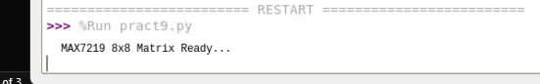
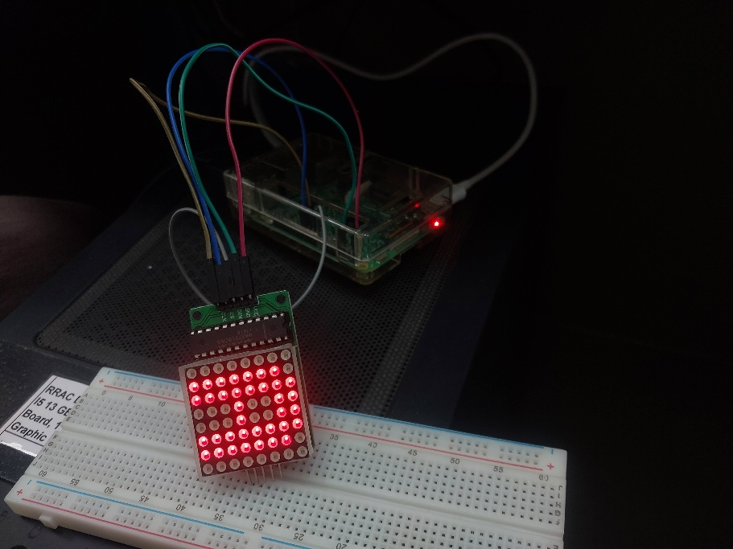
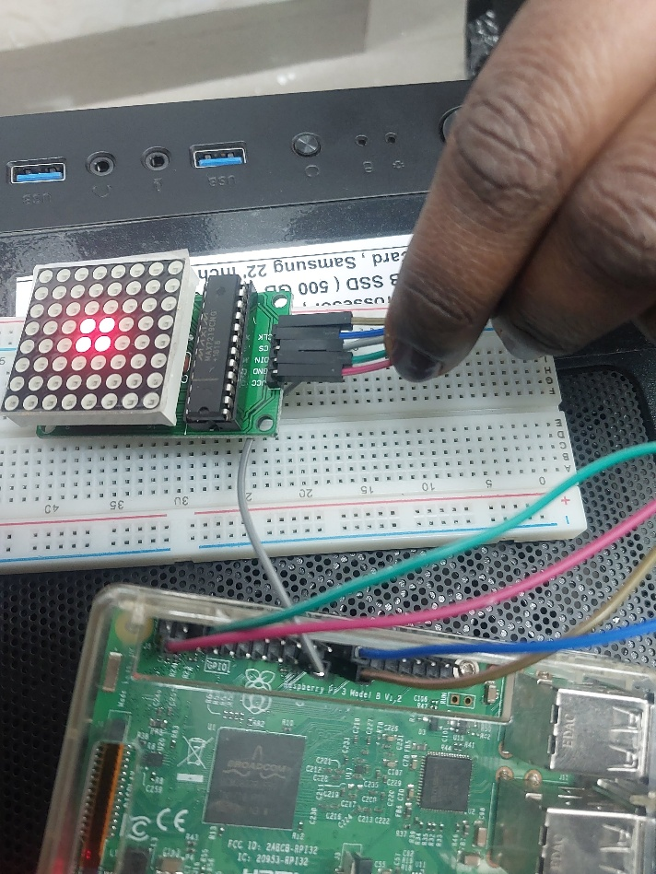

Code for just A: -
from luma.core.interface.serial import spi, noop
from luma.led_matrix.device import max7219
from luma.core.render import canvas
import time

# Initialize SPI connection
serial = spi(port=0, device=0, gpio=noop())

# Initialize LED matrix device
device = max7219(serial, cascaded=1)
device.contrast(50)

print("Displaying Letter A...")

def show_letter_A():
with canvas(device) as draw:
# Define points for letter A
points = [
(2,0),(3,0),(4,0),(5,0), # Top line
(1,1),(6,1),
(1,2),(6,2),
(1,3),(2,3),(3,3),(4,3),(5,3),(6,3), # Middle bar
(1,4),(6,4),
(1,5),(6,5)
]

# Draw points
for x, y in points:
draw.point((x, y), fill="white")

try:
while True:
show_letter_A()
time.sleep(2)

except KeyboardInterrupt:
device.clear()
print("\nStopped. Display cleared.")

Code for RUIA CS IT –
from luma.core.interface.serial import spi, noop
from luma.led_matrix.device import max7219
from luma.core.legacy import show_message
from luma.core.legacy.font import proportional, CP437_FONT
import time

# SPI setup
serial = spi(port=0, device=0, gpio=noop())

# 8x8 matrix
device = max7219(serial, cascaded=1, block_orientation=90, rotate=0)

device.contrast(50)

print("Displaying: RUIA CSIT")

try:
while True:
show_message(
device,
"RUIA CSIT",
fill="white",
font=proportional(CP437_FONT),
scroll_delay=0.1
)
time.sleep(1)

except KeyboardInterrupt:
device.clear()
print("Stopped")

